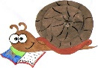
Lyng Primary School Knowledge Organiser
History

History Topic: | All about me | Year 1  Me, Myself and I | Autumn 1
What Step On and Goldilocks words will I use?
Spelling | Definition
chronological | If things are described or shown in chronological order, they are described or shown in the order in which they happened.
present | If things are described or shown in chronological order, they are described or shown in the order in which they happened.
past | The past is the time before the present, and the things that have happened.
future | The future is the period of time that will come after the present, or the things that will happen then.
information | Information about someone or something consists of facts about them.

Background information for parents and teachers
Children will look in depth at their family history.

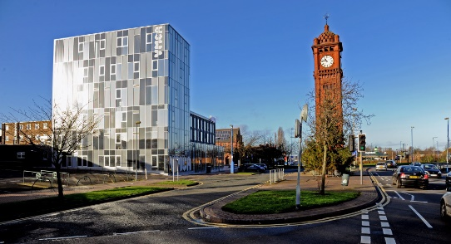
When? (Timeline of key events)
This topic focuses on recent family history and recent West Bromwich history.

There has been new buildings in West Bromwich in the recent years. New Square has opened and the Lyng Estate has been updated.

Lyng Primary school history
The school was formed in January 1981 by the amalgamation of Lyttleton Hall Infant School and Lyng Junior School. A Nursery unit was opened in October 1990.

TRIP/VISITOR
Local area walk. Explore the significant aspects of West Bromwich.
Hook
Using old family photos, children guess who the photograph is from.

Great Quotes
Diversity is not about how we are differ. Diversity is about embracing one another’s uniqueness.
Ola Joseph
Our Storytelling Approach to enhance engagement

People:  YEAR 1  All of the children are special people we will study. | Place:  West Bromwich | Problem:  How did we get here?
Key Questions
Key skills – Taken from Milestone 1 – Sequence of Learning
- Who am I?
- Where do I come from?
- Where do I live?
- What is my favourite place in West Bromwich?
- Who are my family?
- What shops do I go to?
- Where can I go for a fun day out?
- Where is my school?
- How do people in my class get to school?
- How has West Bromwich changed since my parents were born?

- Use words and phrases such as: a long time ago, recently, when my parents/carers were children, years, decades and centuries to describe the passing of time.
- Label time lines with words or phrases such as: past, present, older and newer.
- Observe or handle evidence to ask questions and find answers to questions about the past.
- Ask questions such as: What was it like for people? What happened? How long ago?

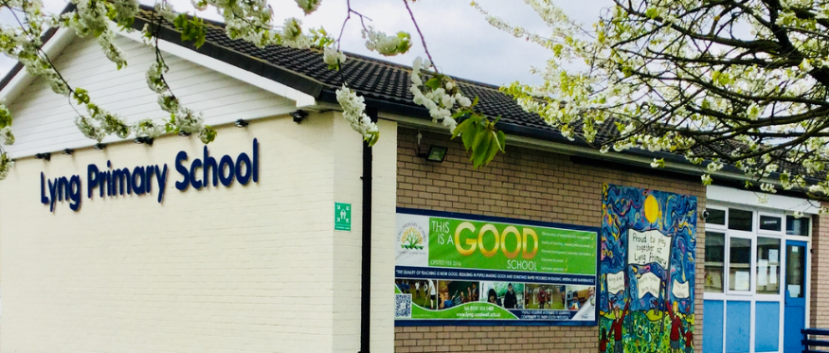
Agreed Outcome
Children can say where they live and where they come from in front of other children in year 1.

